INTERNSHIP REPORT
ON
GOCART – E-COMMERCE WEB APPLICATION
By Upadhyay Ekta Kokilaben
REACT (Roll No ____)
J M Panera Computer Science College
(Affiliated to Bhakta Kavi Narsinh Mehta University)
Payal Hingrajiya
J M Panera Computer Science College

Kamal Ramavat
SoftSpark Tech Studios
Feb 2025-26

Certificate
This is to certify that the student has successfully completed the internship titled GoCart – E-Commerce Web Application during the prescribed internship period. The work carried out by the student is original and has been completed under our guidance and supervision. This internship has fulfilled the requirements prescribed by Bhakta Kavi Narsinh Mehta University.

Acknowledgements
I express my sincere gratitude to the organization and the internship supervisor for providing the opportunity to work on the GoCart – E-Commerce Web Application project. I am thankful to my mentor for continuous guidance, valuable suggestions, and encouragement throughout the internship. I would also like to thank my department and Bhakta Kavi Narsinh Mehta University for their academic support.

Table of Contents
- Cover Page
- Certificate
- Acknowledgements
- Table of Contents
- About the Organization
- Objectives of the Internship
- Tools & Technologies Used
- Project Overview
- Project Architecture
- Functional Modules Description
- Internship Work/Learning Experiences
- Tasks Undertaken & Responsibilities
- Challenges Faced During Internship
- Solutions Implemented
- Learning Outcomes
- Academic Relevance of the Internship
- Conclusion/Summary
- Future Scope
- Attachments/Annexures

About the Organization
SoftSpark Tech Studio is a practical IT training and internship institute based in Porbandar, Gujarat, that specializes in project-based learning for students pursuing IT and computer science-related programs. The institute aims to close the gap between academic curriculum and real software development requirements by offering internships aligned with UGC/AICTE guidelines and driven by live project experience. SoftSpark emphasizes mentorship from industry professionals and regularly evaluates student progress to build analytical and coding skills that are valuable in the IT job market.

Objectives of the Internship
- To gain hands-on experience by working with live software projects under SoftSpark’s internship program.
- To strengthen practical coding skills in Java and other modern technologies.
- To understand software development practices and real-world project workflows guided by industry mentors.
- To enhance problem-solving abilities and analytical thinking through applied learning.
- To fulfil academic internship requirements with a certificate recognized under UGC/AICTE compliance.

Tools & Technologies Used
The following tools and technologies were used during the internship:
Category | Tools/Technologies
Frontend | HTML, CSS, Javascript / React
Backend | Next.js
Database | MongoDB / Local Storage
IDE | Visual Studio Code
Version Control | Git & Github
Testing | Browser Developer Tools

Project Overview:

The GoCart – E-Commerce Web Application is a web-based system designed to allow users to browse products, view product details, add items to a shopping cart, and place orders online. The application focuses on providing a smooth and user-friendly shopping experience with efficient cart handling and navigation. It simulates a real-world e-commerce platform commonly used in online retail systems.

Project Achitecture:
The project architecture follows a structured approach consisting of:
- Presentation Layer: Handles user interface, Product display, and user interactions
- Application Layer: Manages order processing, cart logic, and validations
- Data Layer: Handles Product data, cart items, and order information
This architecture ensures scalability, maintainability, and clear separation of responsibilities.

Functional Modules Description
The system is divided into the following functional modules:
- User Interface Module: Displays Products, categories, and navigation
- Product Management Module: Handles product listing and product details
- Cart Management Module: Handles adding, removing, and updating products/items
- Order Processing Module: Manages order confirmation and order flow
- Data Storage Module: Manages Products data and order records
- Output / Result Module: Displays order summary and confirmation
Each module performs a specific function and works together to ensure smooth system functionality.

Internship Work – LOG Book
During the internship, I worked on the GoCart – E-Commerce Web Application project. The internship provided practical exposure to frontend development, UI design, cart-based workflows, and state management. It helped me understand how modern e-commerce applications are designed and implemented using web technologies.

Tasks Undertaken and Responsibilities:
Sr. No. | Task Name | Hours Spent
 | Gaining basic knowledge of the programming language and framework used in the project | 4
 | Understanding internship guidelines, objectives, and project scope | 3
 | Studying fundamental concepts related to web/application development | 4
 | Preparation and understanding of detailed project requirements | 5
 | Analyzing similar existing systems and applications | 4
 | Studying overall project structure and folder organization | 6
 | Designing user interface flow and component hierarchy | 6
 | Creating basic UI layouts and reusable components | 8
 | Implementing product listing and product detail logic | 10
 | Developing cart management and navigation components | 14
 | Implementing core frontend logic for order handling | 24
 | Integrating data handling and state management | 10
 | Performing code modification and feature enhancement as per requirements | 14
 | Debugging compilation errors and resolving runtime issues | 12
 | Testing application functionality and validating outputs | 11
 | Improving UI responsiveness and user experience | 5
 | Preparing project documentation and collecting screenshots | 6
 | Writing internship report and final submission preparation | 4
 | Total Hours | 120

Challenges Faced During Internship
- Understanding complex project logic
- Debugging unexpected runtime errors
- Managing time effectively across tasks
Solution Implemented
- Used mentor guidance and documentation
- Apply Debugging tools and systematic testing
- Improved planning and task scheduling

Learning Outcomes

Knowledge Gained:
- Understanding of web application logic and data handling.
- Knowledge of frontend technologies and project setup.
- Familiarity with application structure and dynamic feature implementation.

Skills Developed:
- Frontend component implementation.
- Debugging and troubleshooting logic flows.
- Logical and analytical thinking for application enhancements.

Employability Enhancement:
- Increased confidence in developing practical web applications.
- Better understanding of real project workflows.
- Enhanced readiness for future academic or professional software development tasks.

Academic Relevance of the Internship
This Internship reinforced academic concepts such as:
- Programming Fundamentals: The internship enhanced the understanding of programming fundamentals such as variables, data types, control structures, loops, functions, and object-oriented concepts. Writing real project code helped in applying logical thinking and improving problem-solving skills. The practical exposure reinforced how programming constructs are used to develop functional and efficient applications

- Software Engineering Principles: The internship reinforced software engineering principles such as requirement analysis, modular design, code reusability, and maintainability. Concepts like system planning, development life cycle, debugging, and testing were applied practically. The importance of writing clean, readable, and structured code was understood through hands-on development.

- Database Management Systems: The project work helped in applying database management concepts such as data storage, retrieval, updating, and deletion. Understanding how applications interact with databases strengthened knowledge of CRUD operations, data consistency, and basic database design principles. It also enhanced understanding of how data is managed efficiently in real-world systems.

- System Design And Architecture: The internship reinforced system design concepts by understanding how an application is divided into different layers such as presentation, logic, and data layers. Learning about component-based architecture, modular development, and data flow improved the understanding of scalable and maintainable system design.

- Web/Application Development Concepts: Academic concepts related to web or application development such as client-server architecture, user interface design, and user experience principles were practically implemented. This helped in understanding how frontend and backend components work together to deliver a complete application.

- Testing and debugging techniques: The internship strengthened academic knowledge related to software testing and debugging. Practical exposure to identifying logical errors, runtime issues, and performance problems enhanced the understanding of testing methodologies and quality assurance practices.

- Project management and documentation: The internship reinforced academic concepts related to project planning, time management, and documentation. Preparing reports, maintaining project records, and organizing tasks helped in understanding the importance of documentation and systematic project execution.

- Professional and Ethical Practices: The internship also highlighted professional practices such as version control, code ethics, responsibility, and collaboration. These practices align with academic learning outcomes and prepare students for professional environments.

Conclusion / Summary

Reflection on overall experience:
- The internship provided meaningful practical exposure to real-world software development practices.
- It helped in understanding the application of theoretical knowledge in a practical environment.
- The project-based learning approach enhanced clarity of programming concepts.
- Guidance and mentorship contributed significantly to skill development and confidence building.
- The overall experience was structured, informative, and professionally enriching.

Key Takeaways for Future Career or Academic Growth:
- Improved readiness for advanced academic projects and practical examinations.
- Enhanced confidence in handling software development tasks independently.
- Better understanding of industry expectations and development workflows.
- Strengthened foundation for pursuing a career in software development.
- Developed a disciplined and problem-solving approach toward technical challenges.

Future Scope
The future scope of the GoCart includes several technical enhancements that can improve scalability, security, performance, and usability of the system.
- Feature Enhancement

  - Addition of advanced functional modules based on user requirements
  - Implementation of role-based access control (RBAC)
  - Integration of real-time notifications and reporting features

- Performance Optimization

  - Code refactoring for better maintainability and efficiency
  - Optimization of database queries and data handling
  - Implementation of caching, lazy loading and pagination techniques

- Security Improvements

  - Implementation of token-based authentication (JWT/OAuth)
  - Secure API Communication using HTTPS
  - Input validation and protection against common vulnerabilities

- User Experience Enhancement

  - Improved UI responsiveness across devices
  - Accessibility improvements and usability enhancements
  - Components reusability for consistent interface design

Attachments / Annexures

Screenshots of the Frontend
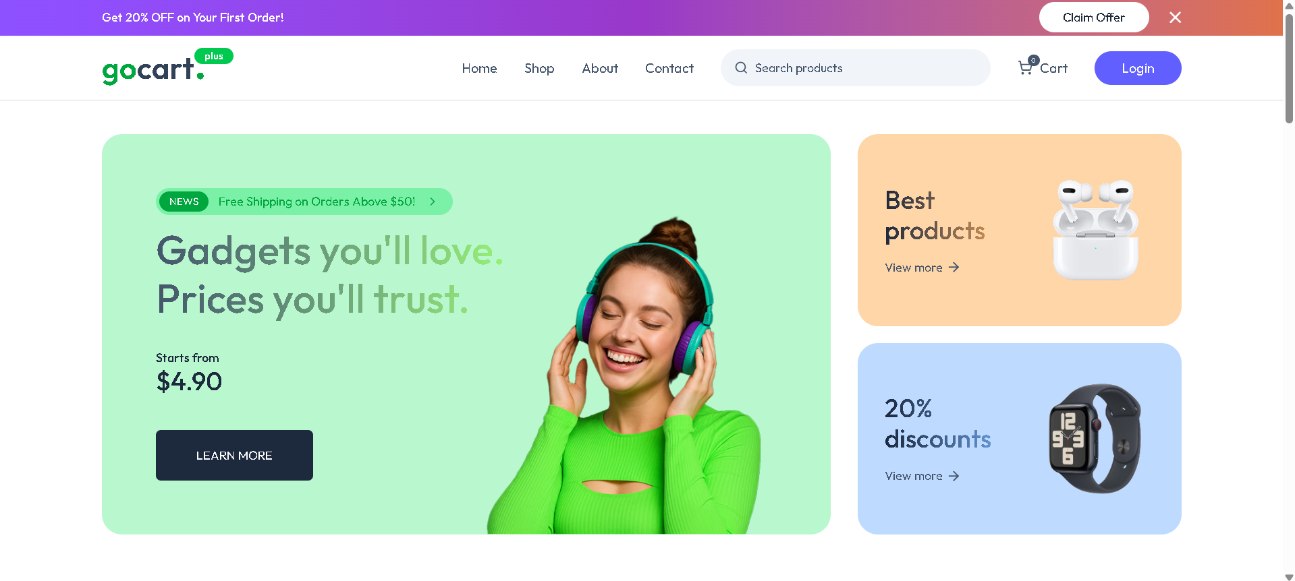
1.Home Screen
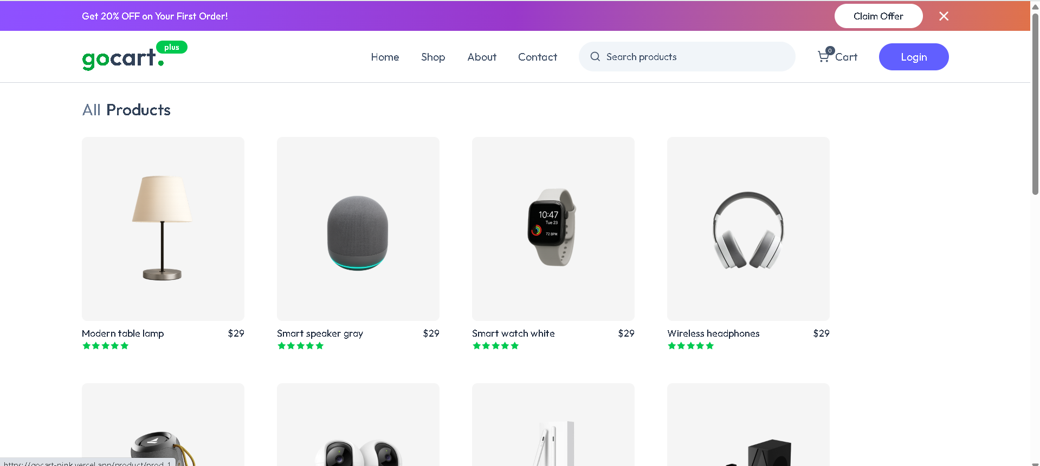
2.All products Screen
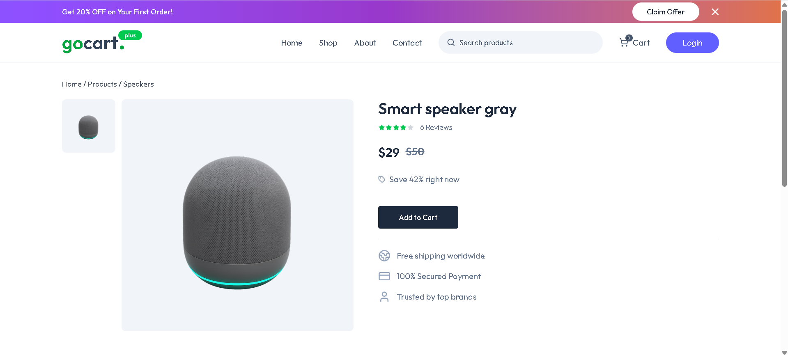
3.Product Detail Screen
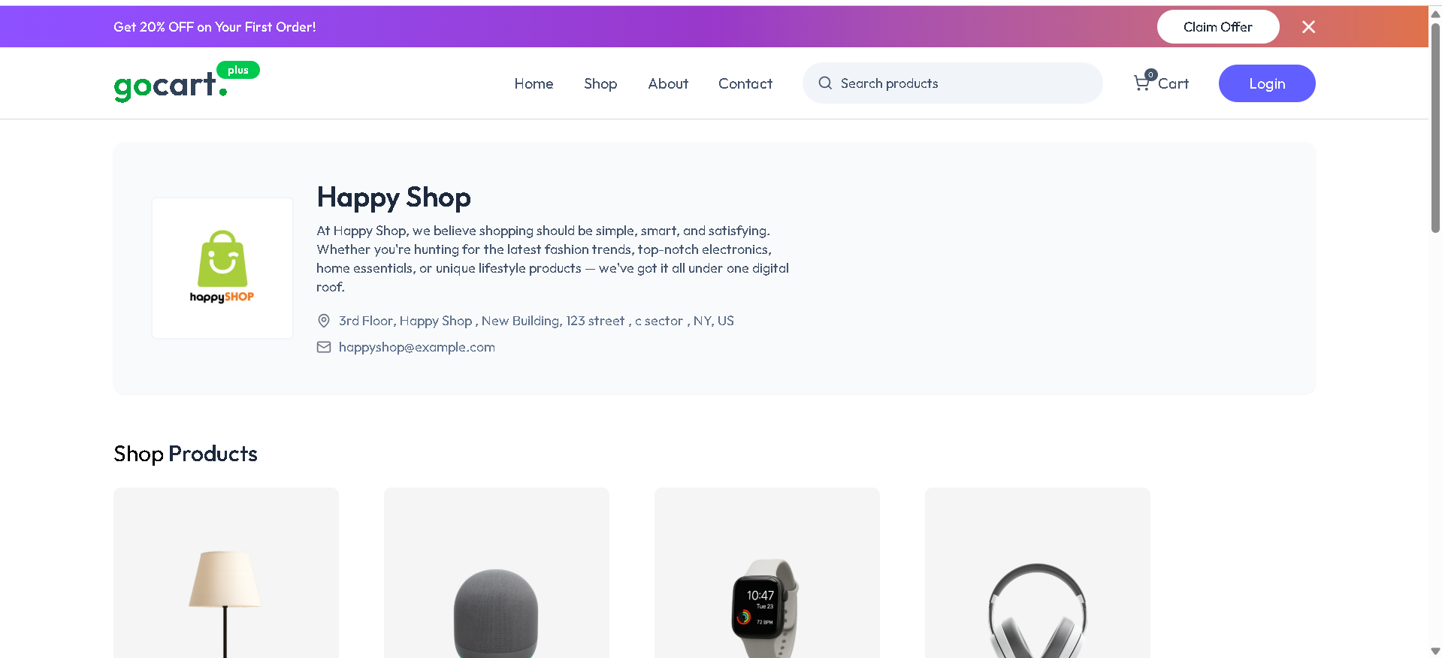
4.Specific Shop Screen

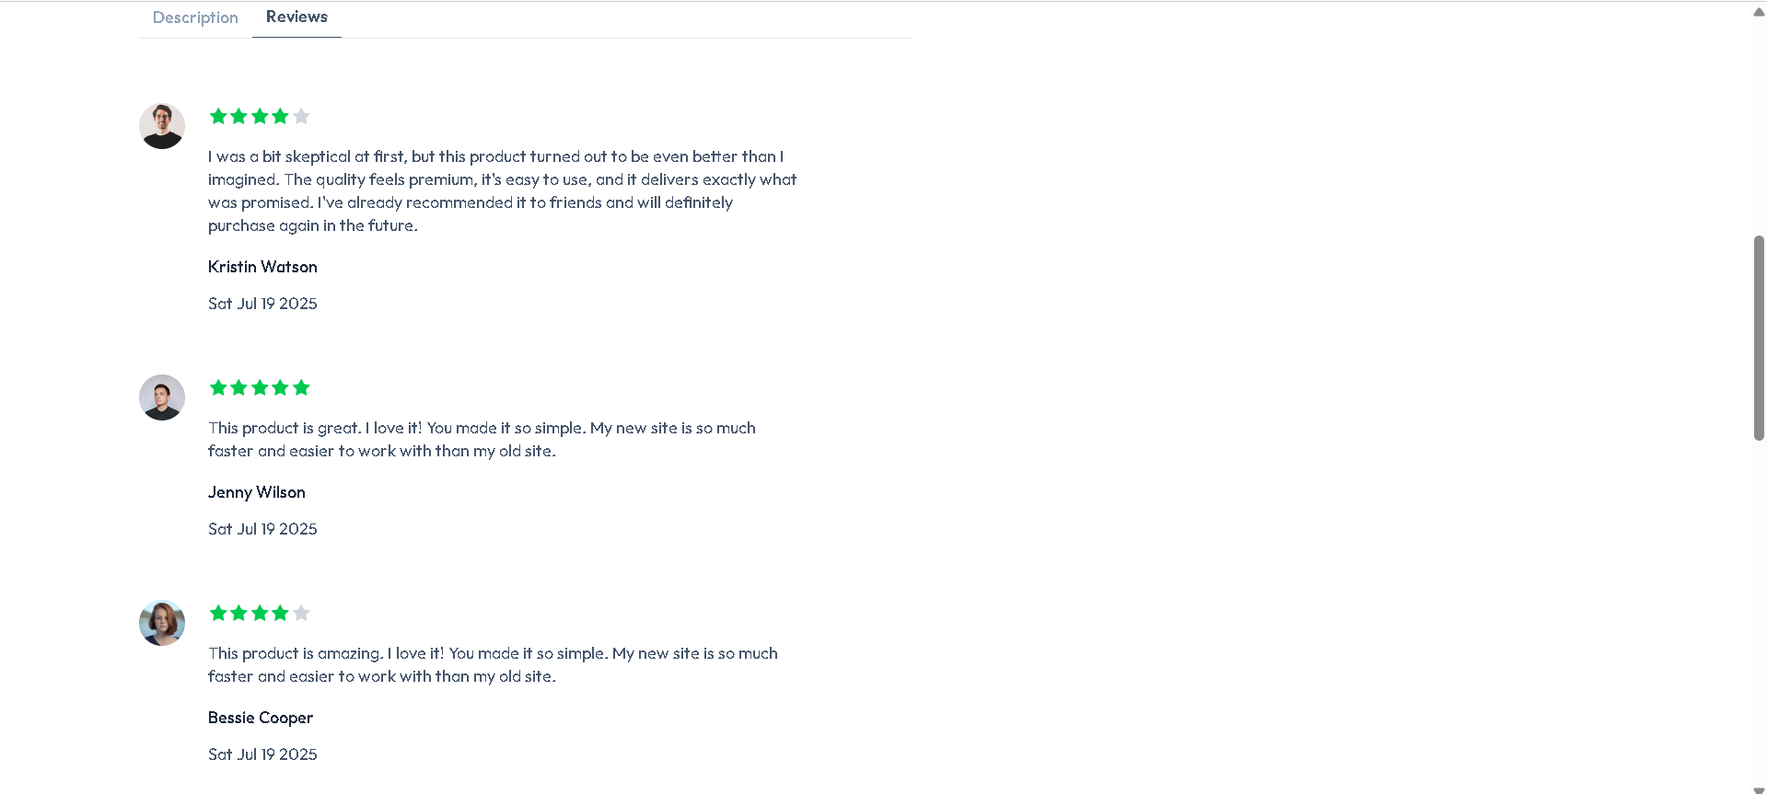
5.Review Screen


6.Footer of the Application
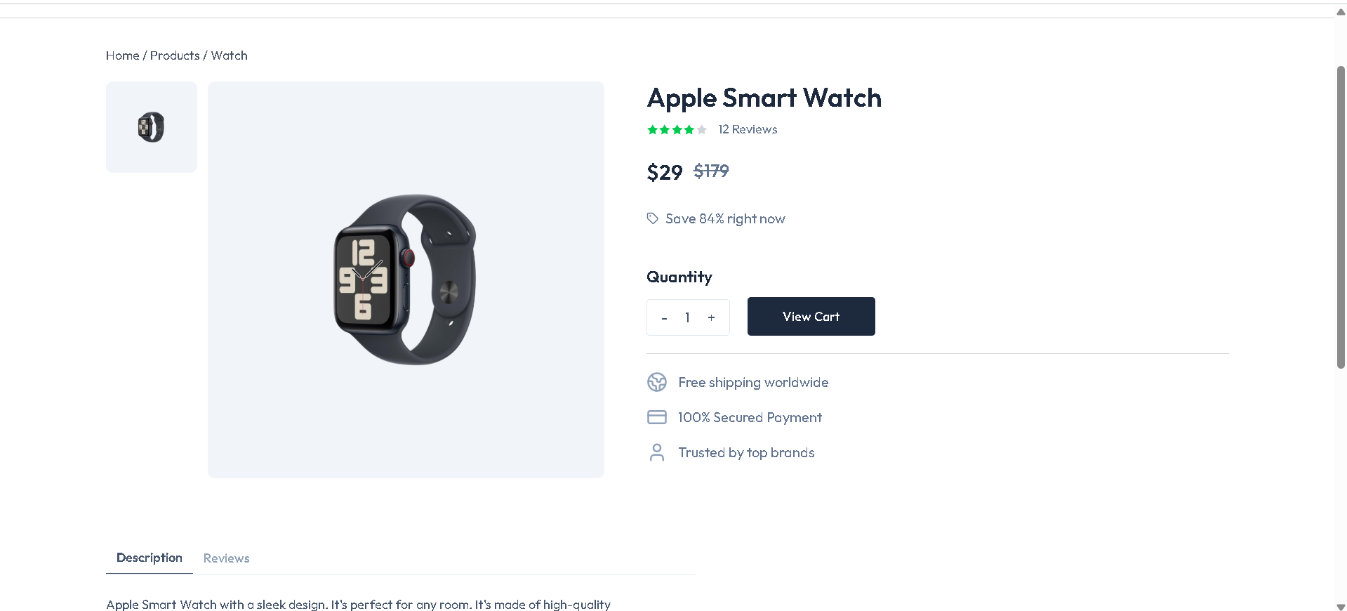
7.Add to Cart Screen

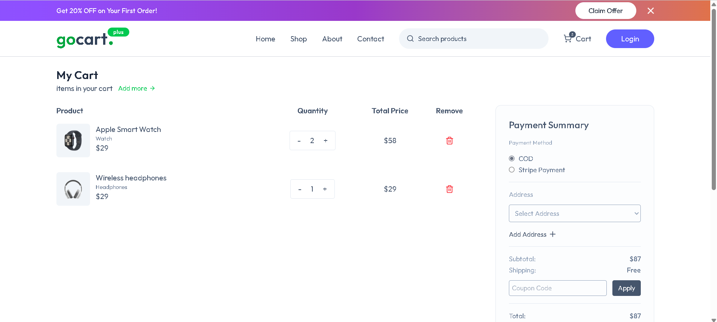
8.Cart Screen

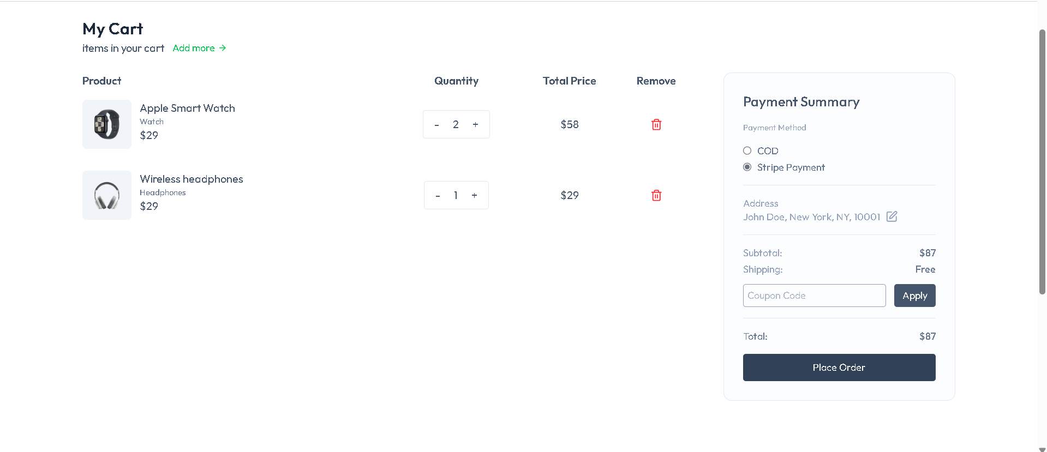
9.Payment Option Screen

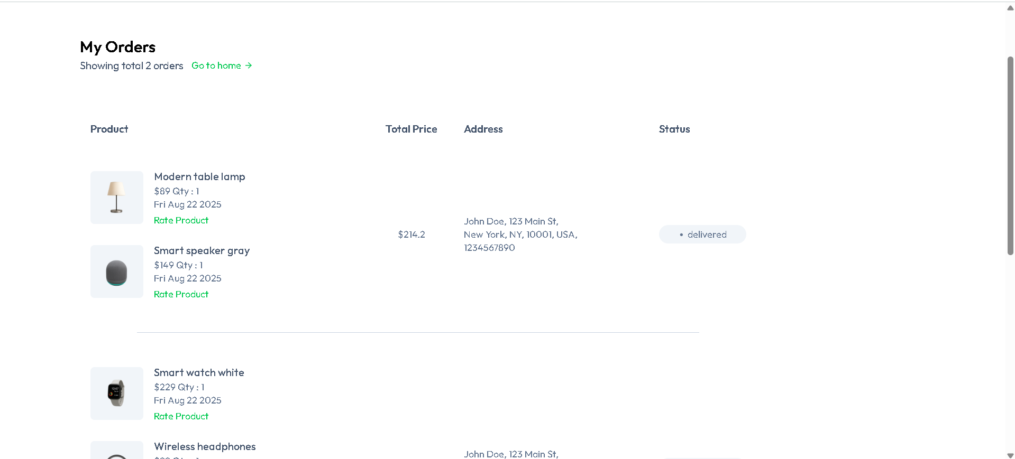
10.My Orders Screen
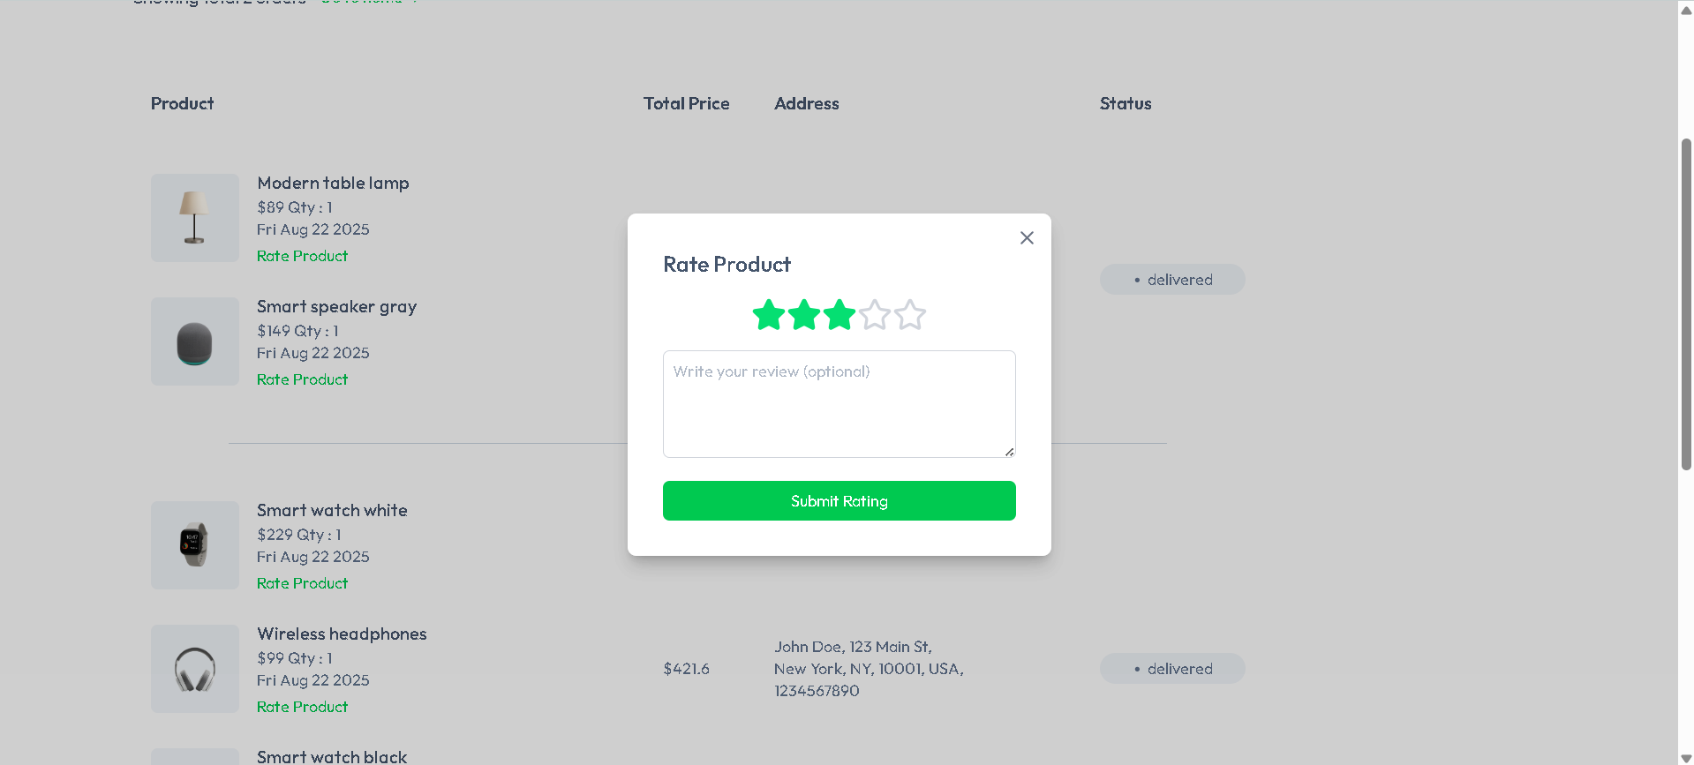
11.Rating Screen

